Name : Dahlia Shehata Mahmoud
ID : 28
Lab Assignment 1: Shell and System Calls

Code Organization:
The code is divided between 6 main c files and their equivalent headers:

command_parser.c : responsible for parsing the commands over different split as space/tab for normal Linux commands and over “:” for paths .
It handles the splitting for the echo command too and call functions from other files to replace the environment variables by their equivalent values.

commands.c : handles different commands and their special cases such as “cd” , ls and also it validates any command y searching in the binary file
if not found , it sends invalidation message to caller function.

environment.c : responsible for the environment variables and their handling
setting the variables,getting them,replacing with environment values,formatting the variable by removing”$” and also sets up the environment for the beginning of shell.

variables.c: contains the main global variables used in the program ,their declaration as well as the environment paths stored.

file_processing.c: responsible for reading and writing in the log and history files as well as openning the batch file and sending the signal for the child process termination to be written in the log file.

main.c: the main program calls set-up environment function first and identifies the number of arguments to determine the mode type: batch or interactive and then execute the shell loop which calls different function from different files and is responsible for forking the process.

Main Functions:

Function name | Responsible for
char**parse_command(const char* command,char split) | Parsing the commands over space and  “ : “ for paths
char** Splitter(const char*command,char split) | Split the command in char* where environment variables will be replaces later
void cd(char** parsed) | Responsible for cd command with parameters “~” or ” / ”
char* getCommand(char**src,char*cmd) | Compare the command with that in the binary files to validate it
char* getEnvironmentVars(char* envName) | Get environment variables
int setEnviroVars(char**parsed,int arg) | Set their values
void ReplaceVarsWithVals(char**parsed) | Replace variables with values
void setup_environment( void ) | Set the PATH ,HOME ,PWD before starting the shell
void read_from_history_file() | Read from history file
FILE * write_in_history_file(char input[]) | Write in history file
void signalHandler() | Send the signal of process child termination
int setBatchEnv(char* path) | Set up the path of the batch file from the main argument
pid_t execute(pid_t pid,char**parsed,char *command) | Responsible for forking processes
void shell_loop() | The main shell loop where commands are scanned and executed

Compiling and running Manual:

- open terminal and cd the path of the program
- type “make” to get the “out” file here named shell
- ./shell for interactive mode.
- ./shell batchfile_path for batch mode.

Sample runs:
history file:
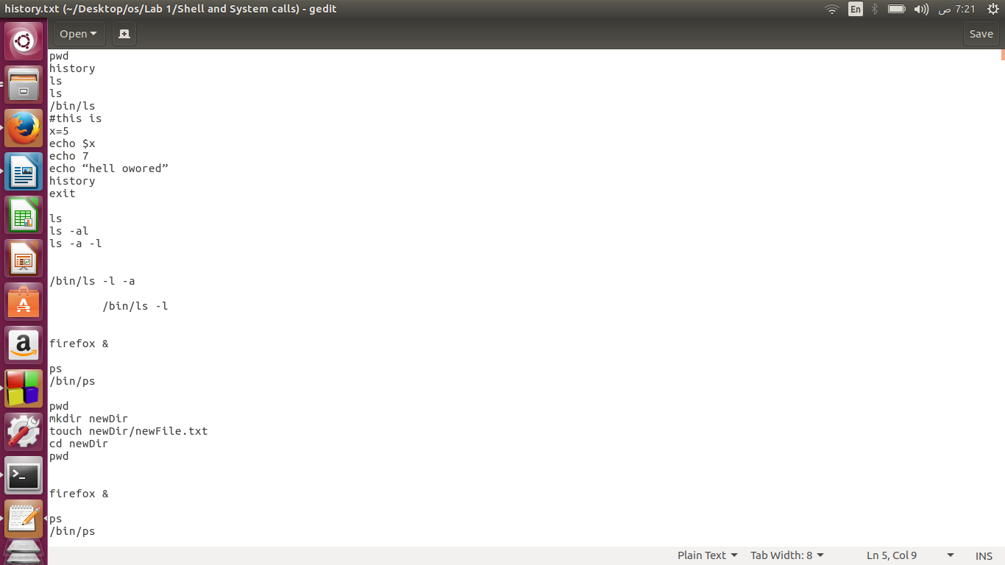

log file :

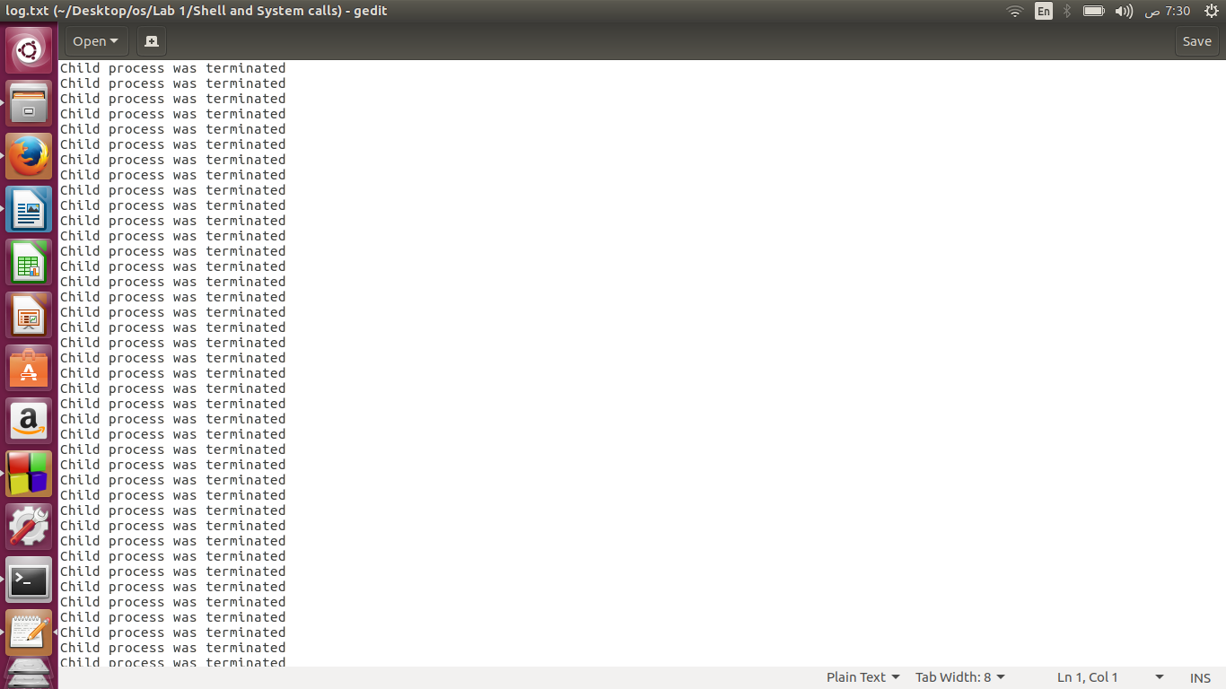

batch file :
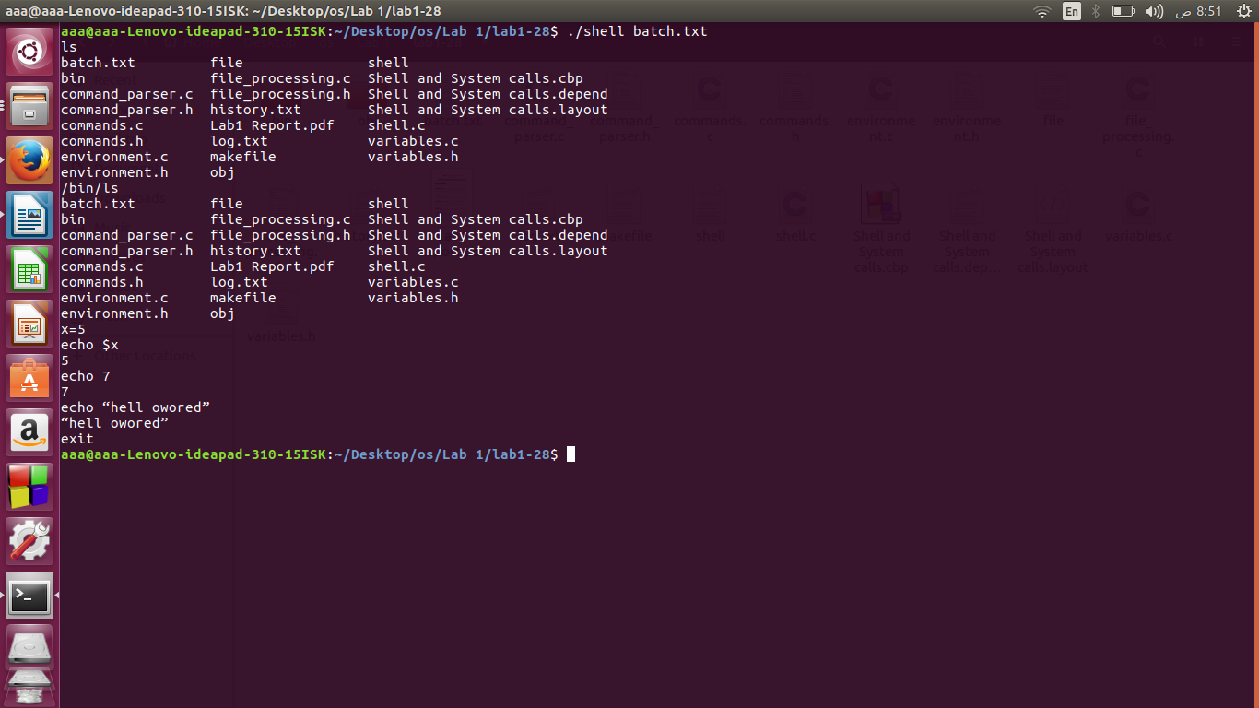
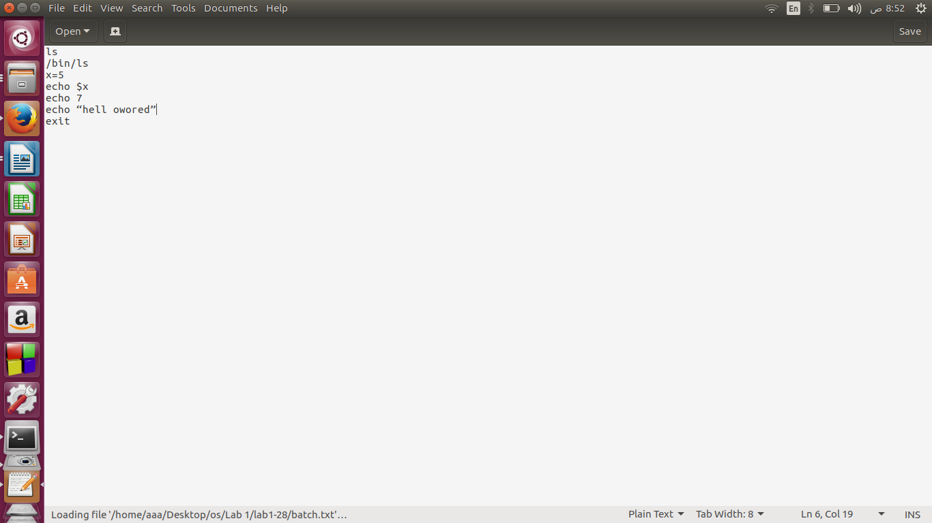

Interactive:
